# **ShoppyGlobe Backend: CRUD Operations with Screenshots**

## **1. Import Products (via npm run import or npm run dev)**

**Description:** Running the import script before the index.js to seed DummyJSON products into MongoDB.

npm run dev # or node scripts/importProduct.js(seprately)

**Success Example:**

* Imported 30 new products.

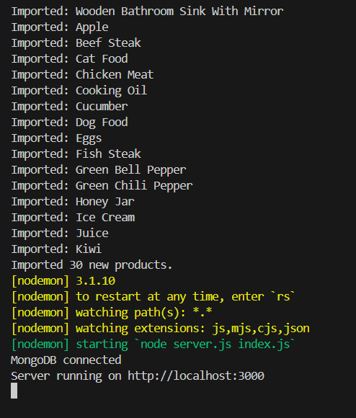

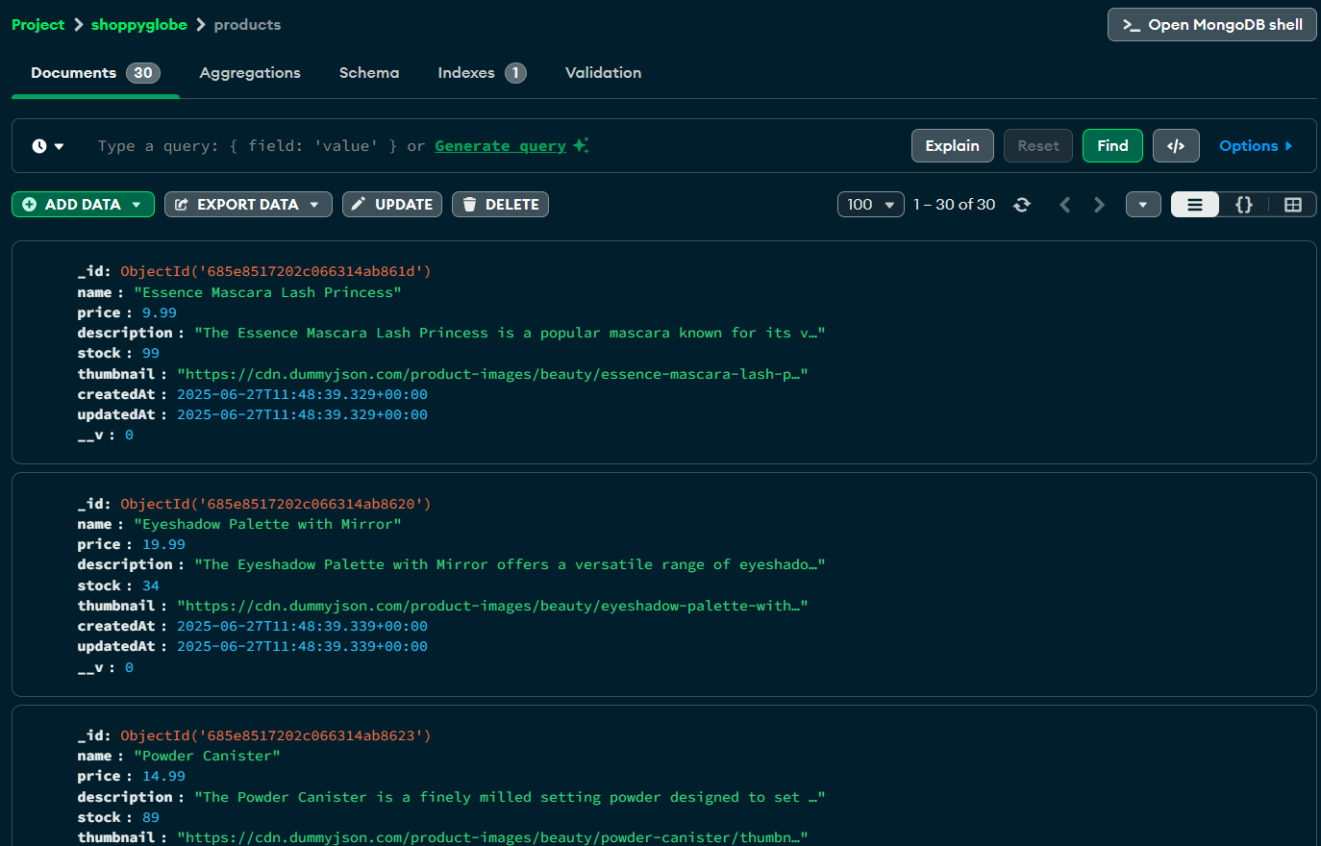

Or:

* All products already imported.

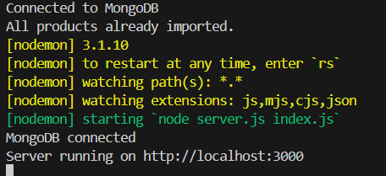

**Error Example:**

MongoDB connection failed:

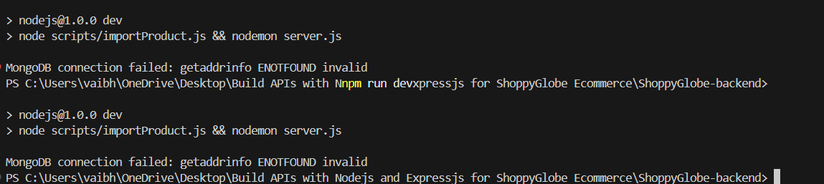

## **2. GET - All Products**

**Route:** GET /products

**Success Response (200):**

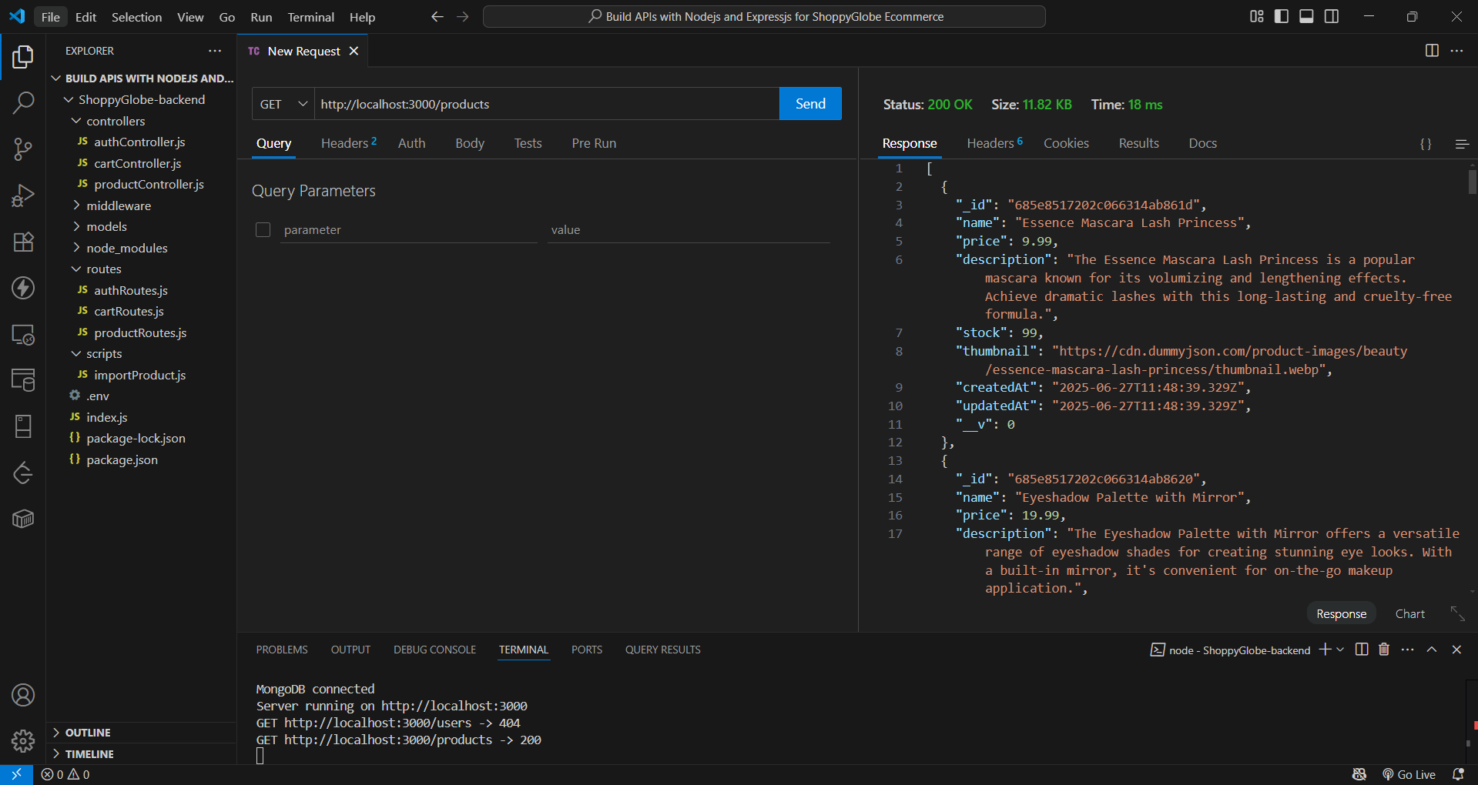

**Error Response(Route not found:**

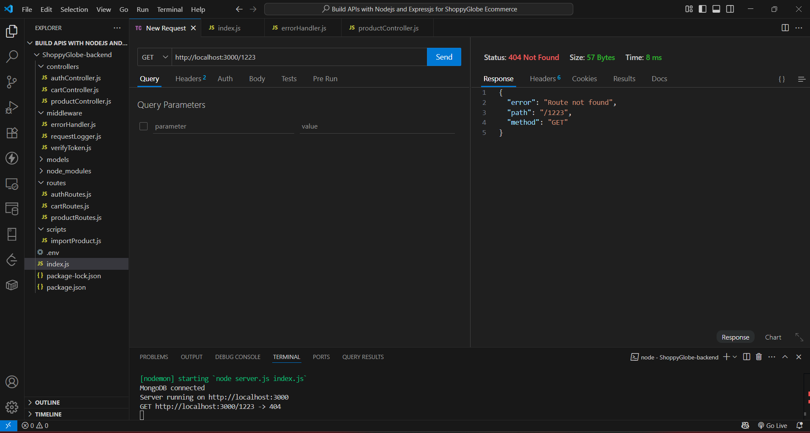

## **3. GET - Single Product by ID**

**Route:** GET /products/:id

**Success Response (200):**

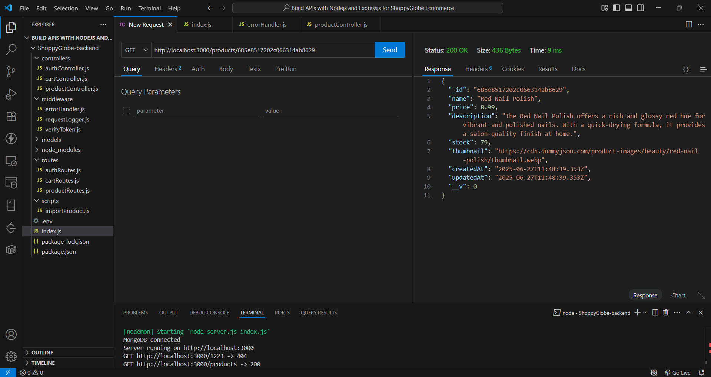

**Error Response (404 - Not Found):**

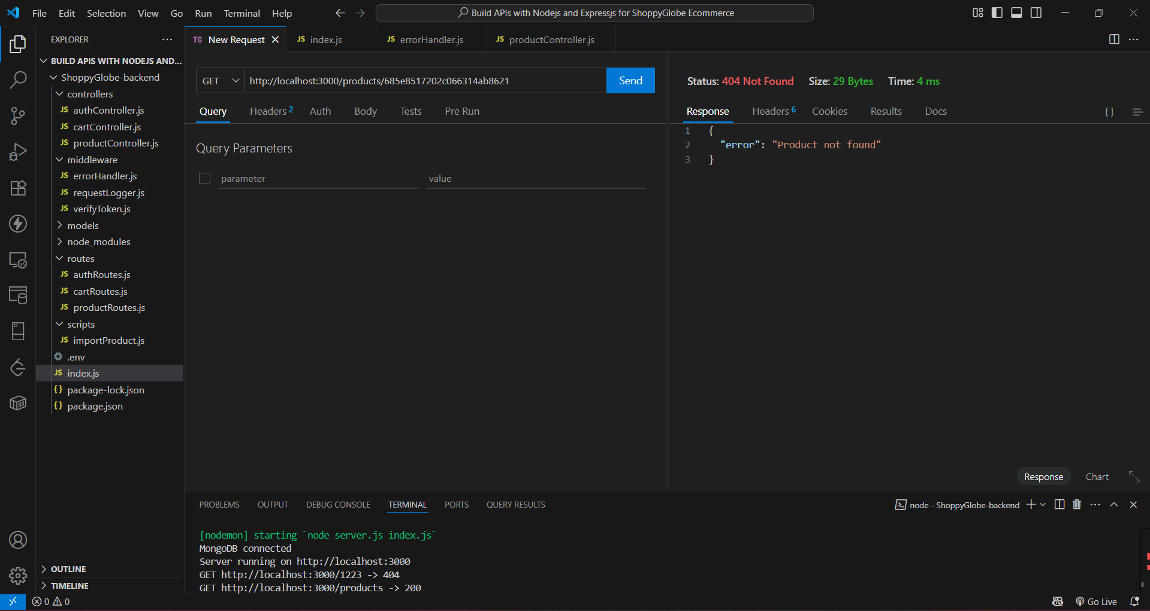

**Error Response (500 - Invalid ID):**

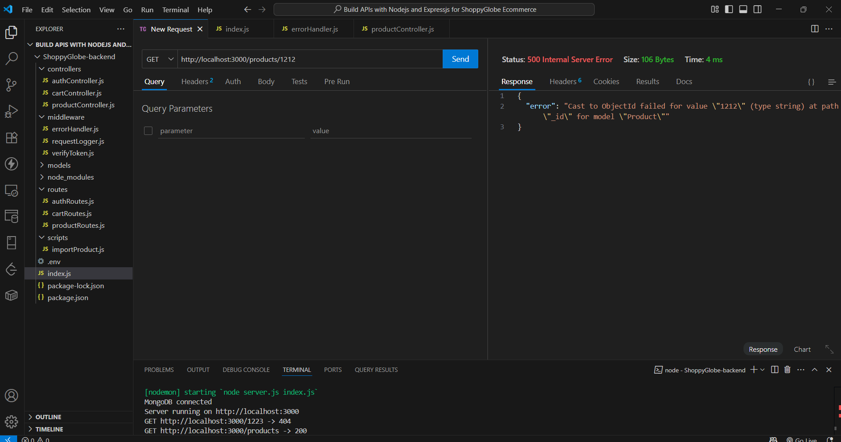

## 

## **4. User Authentication**

#### **A. Register New User**

**Route:** POST /register

**Success Response (201):**

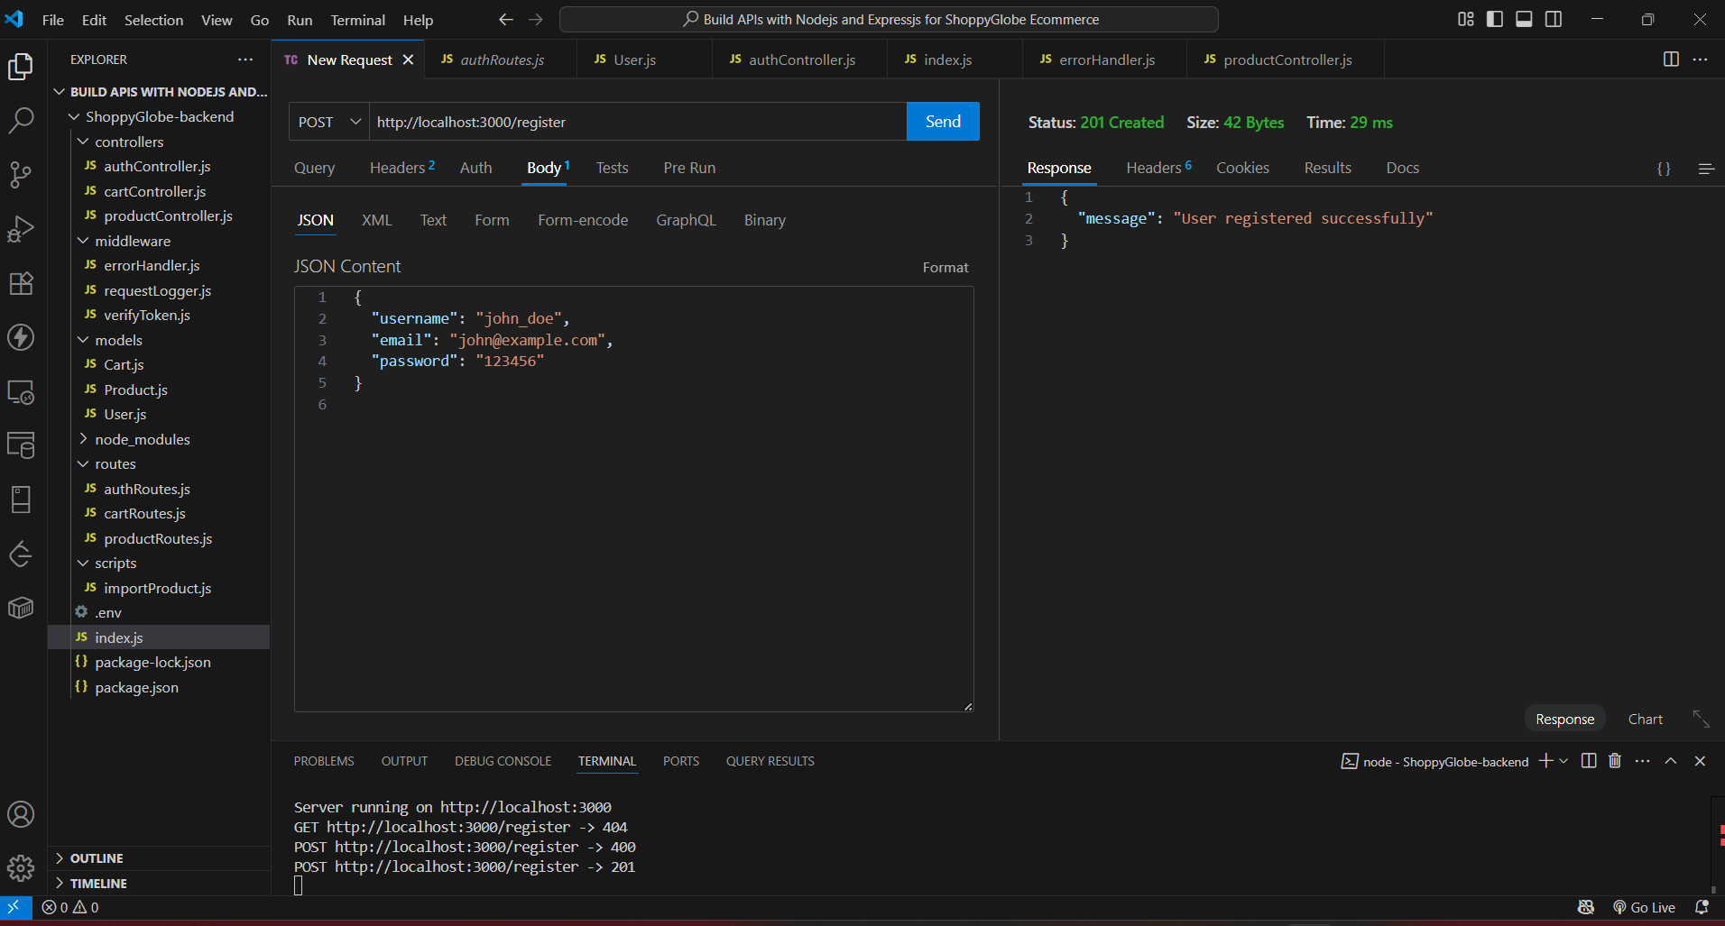

**MongoDB Compass showing added user.**

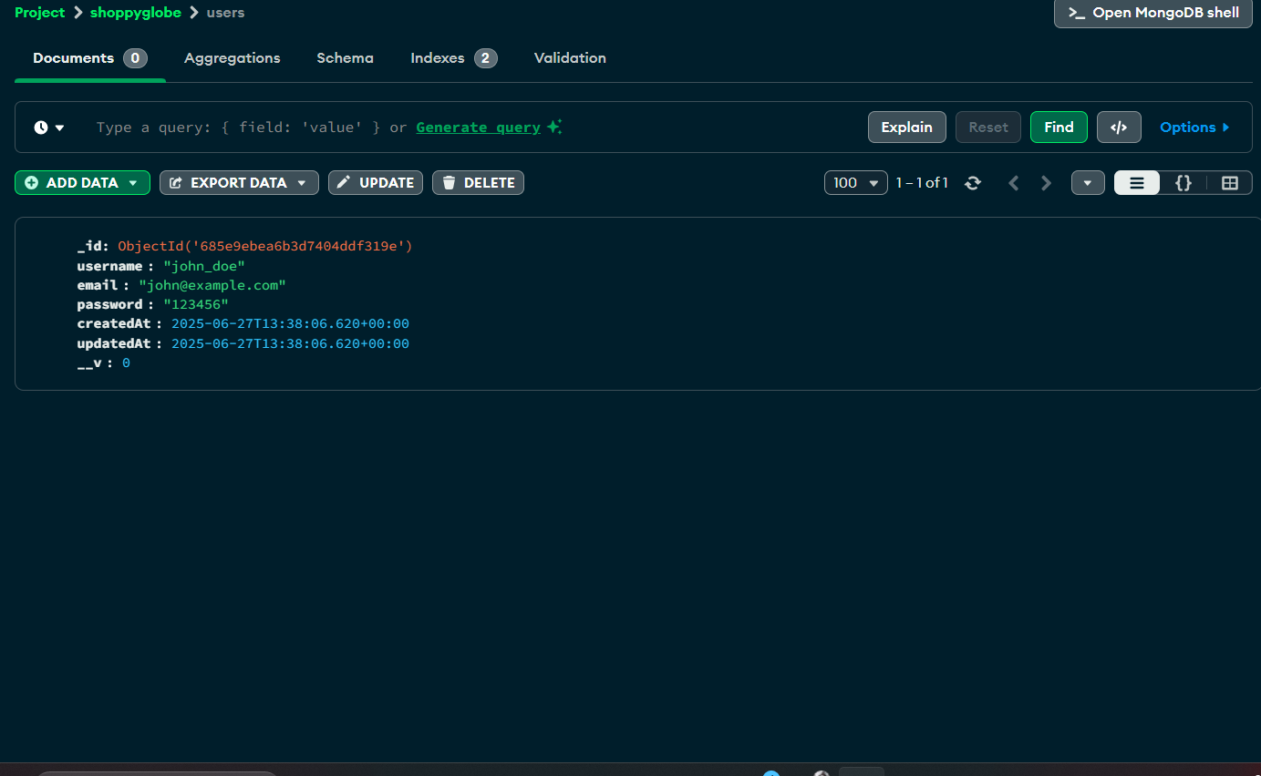

**Error Response (400 - Missing Fields):**

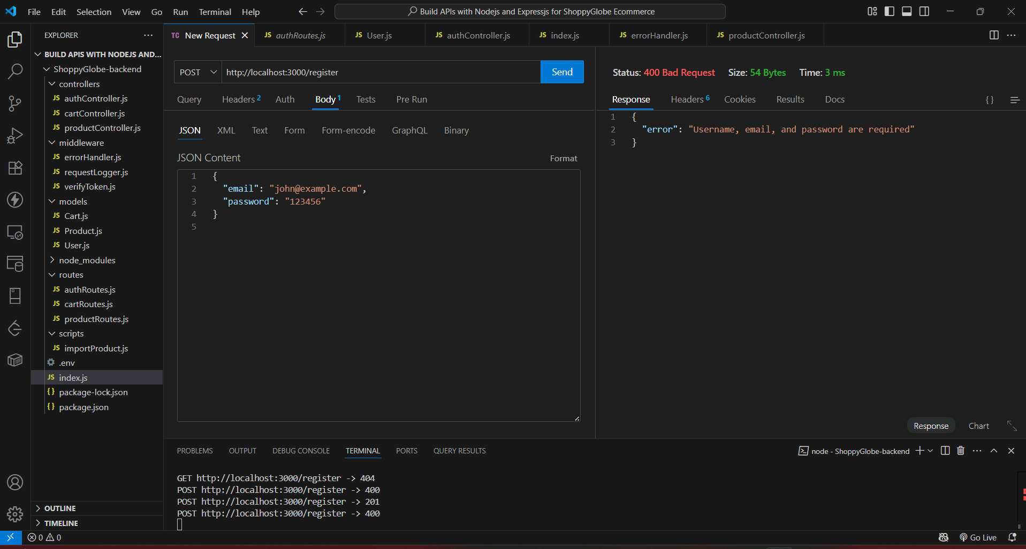

**Error Response (409 - Duplicate Email):**

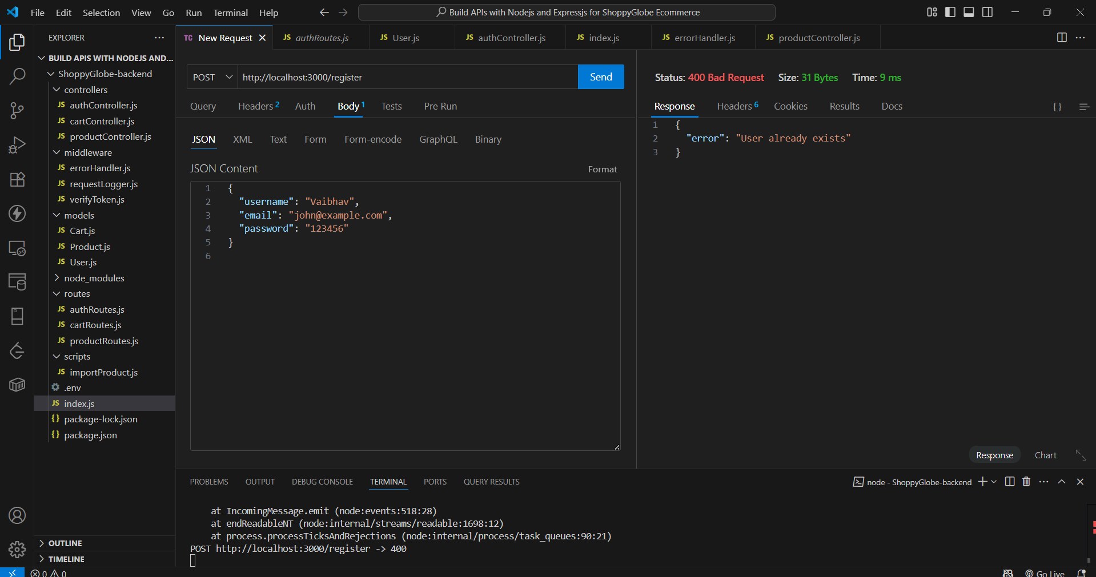

#### 

#### **B. Login User**

**Route:** POST /login

**Success Response (200):**

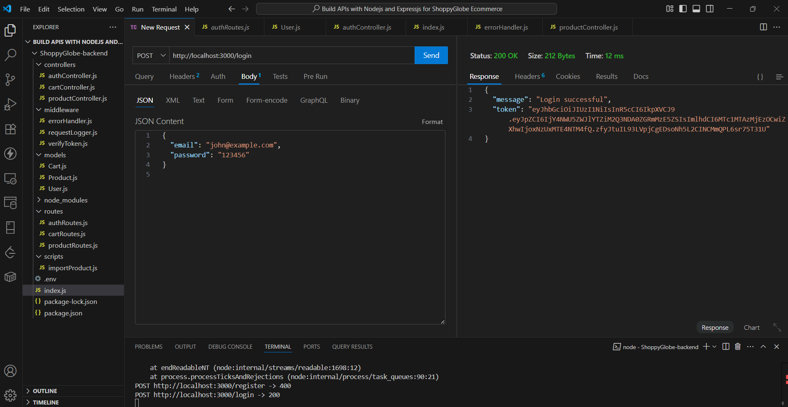

**Error Response (400 - Missing Fields):**

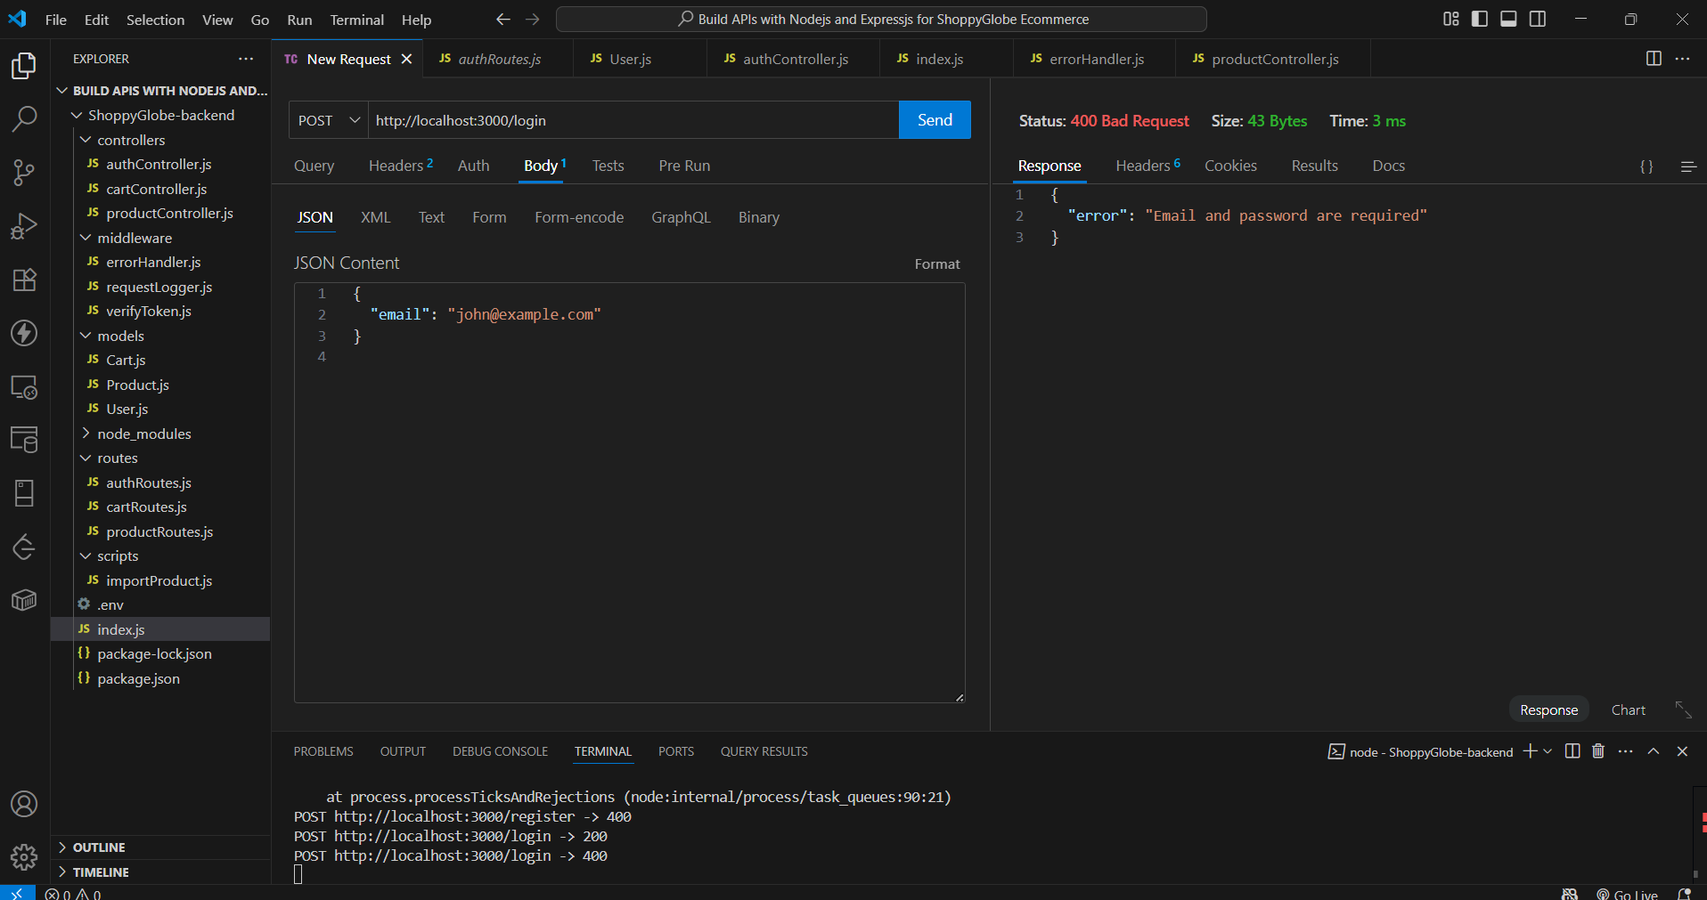

**Error Response (401 - Invalid Credentials):**

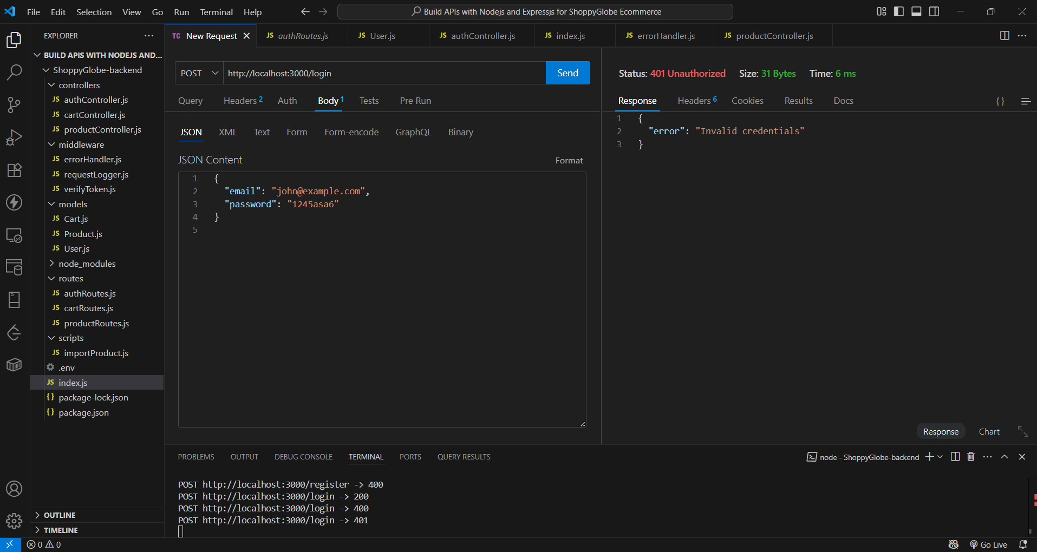

## 

## **5. POST to Cart (Add Item)**

**Route:** POST /cart  
**Headers:** Authorization: JWT <token>

**Success Response (200):**

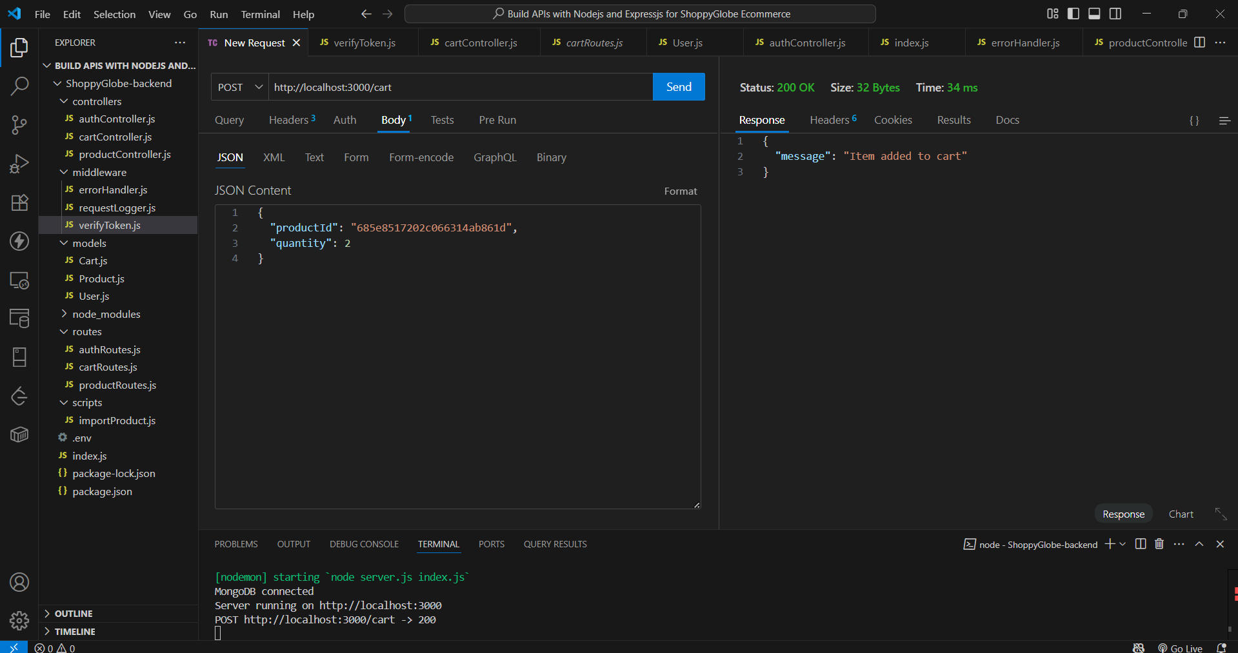

**Mongo Compass Item has added to the database**

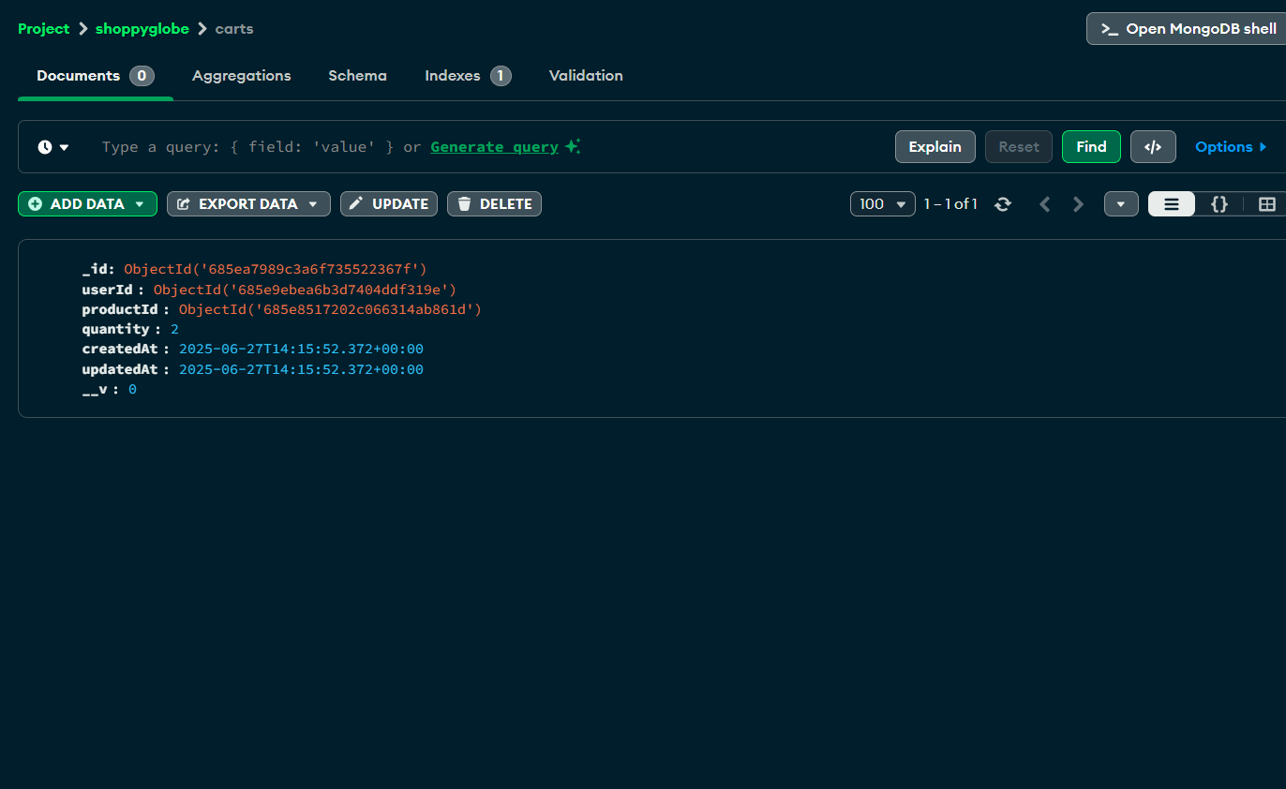

**Error Response (401 - Unauthorized):**

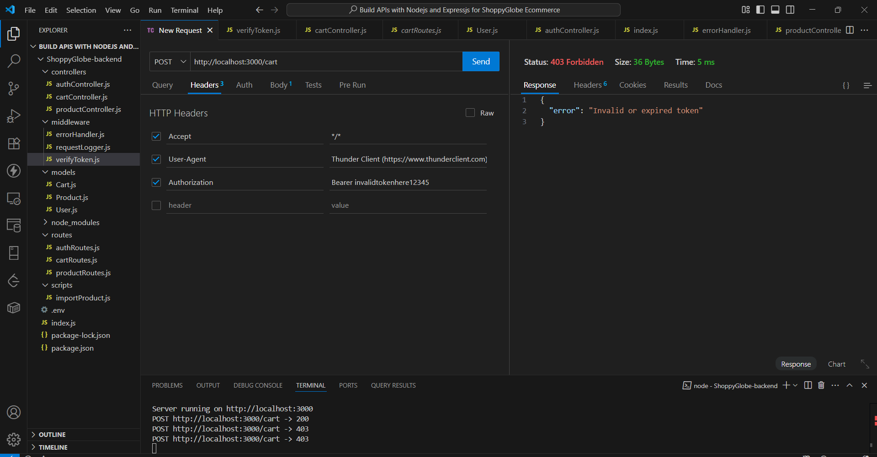

**Error Response (400 - Validation Error):**

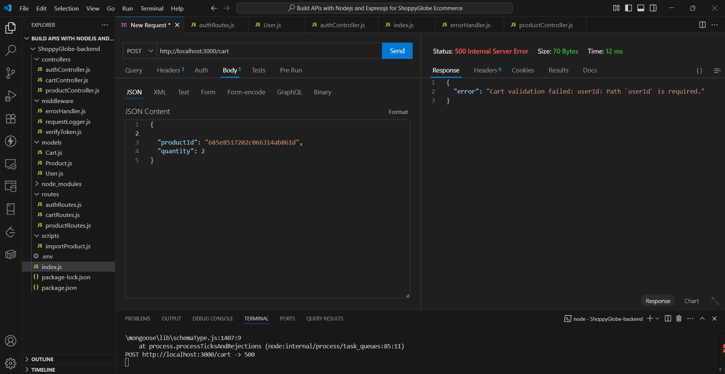

## 

## **5. PUT to Cart (Update Quantity)**

**Route:** PUT /cart/:id  
**Headers:** Authorization: JWT <token>

**Success Response (200):**

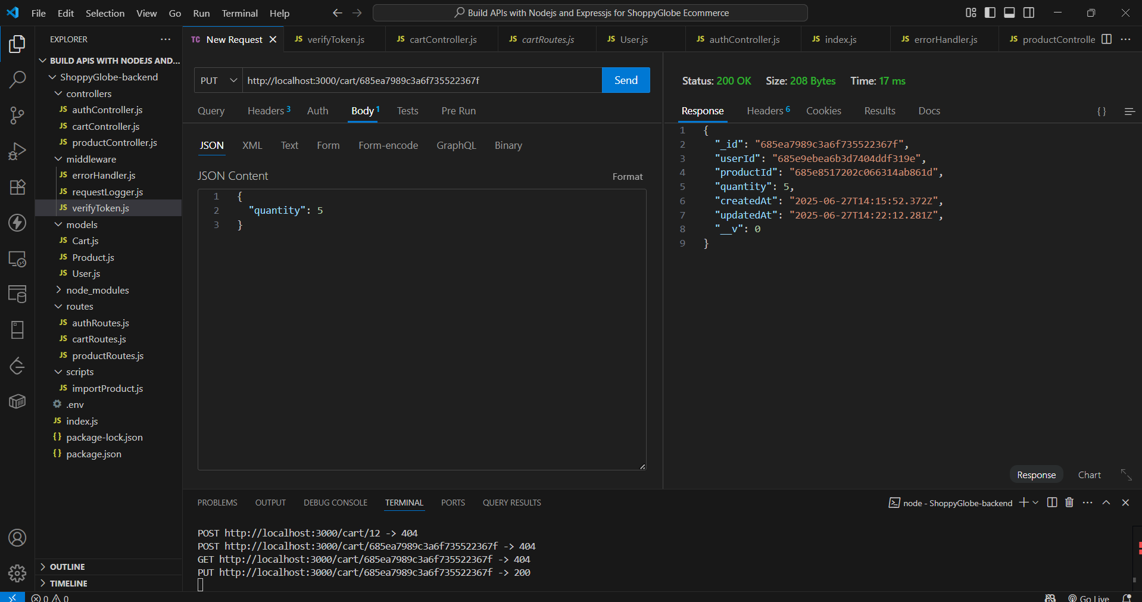

**Mongo Compass Updated:**

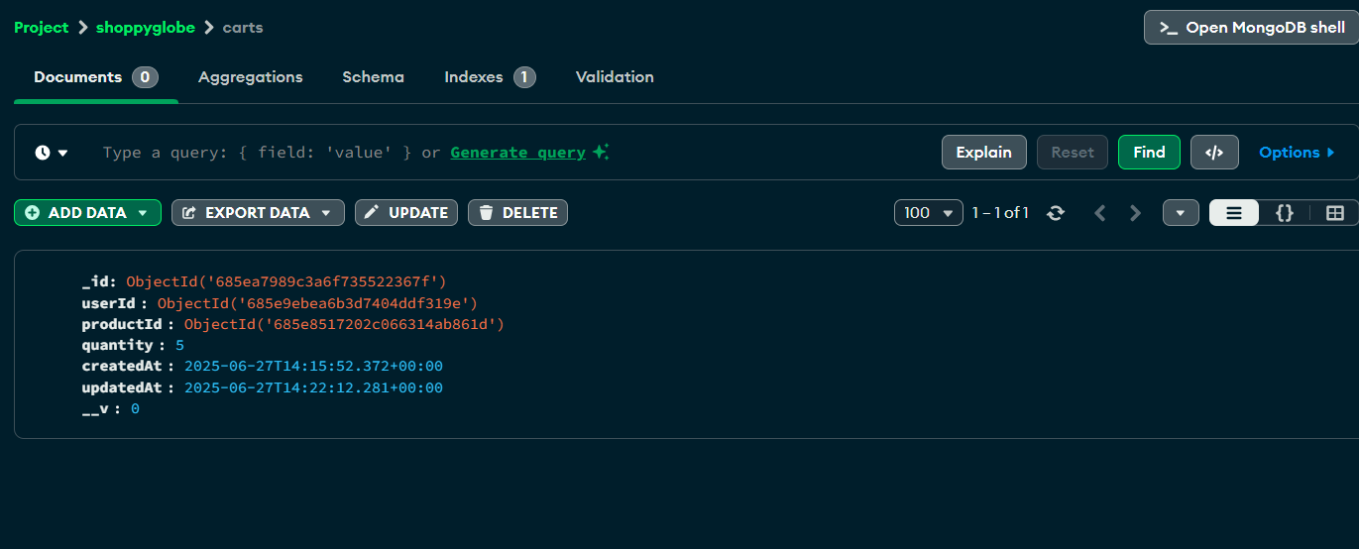

**Error Response (404):**

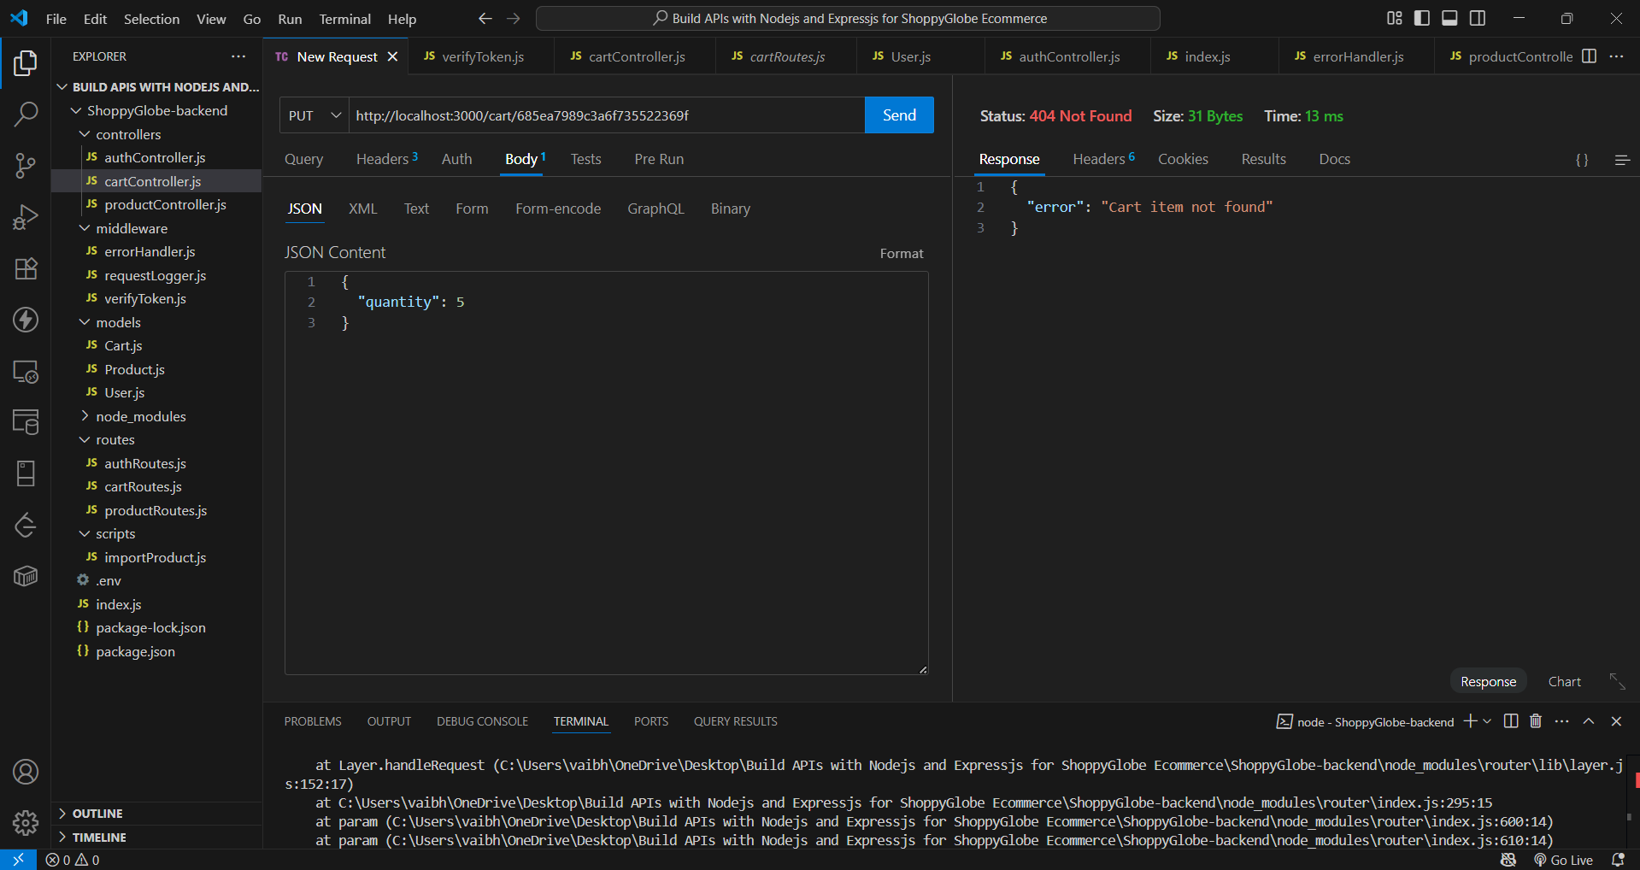

**Error Response (401):**

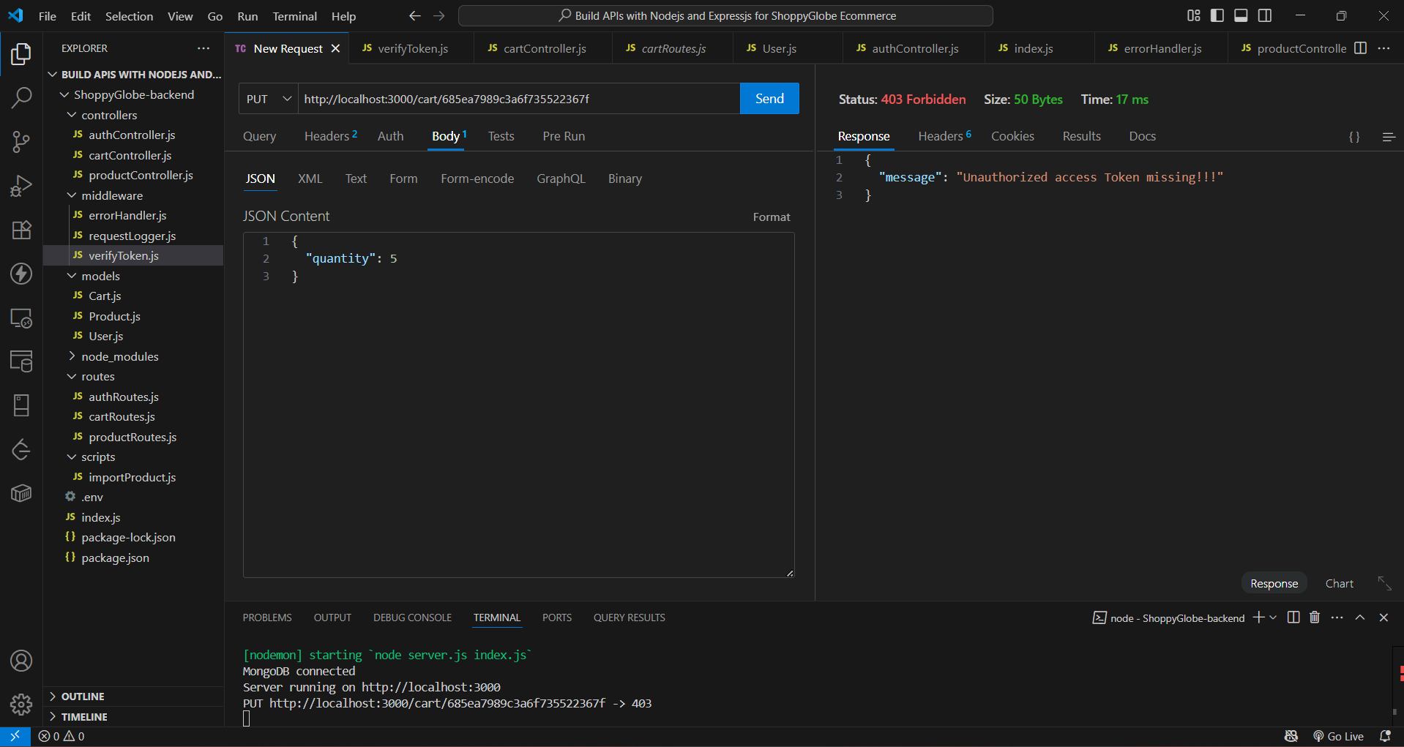

**Error Response (404):**

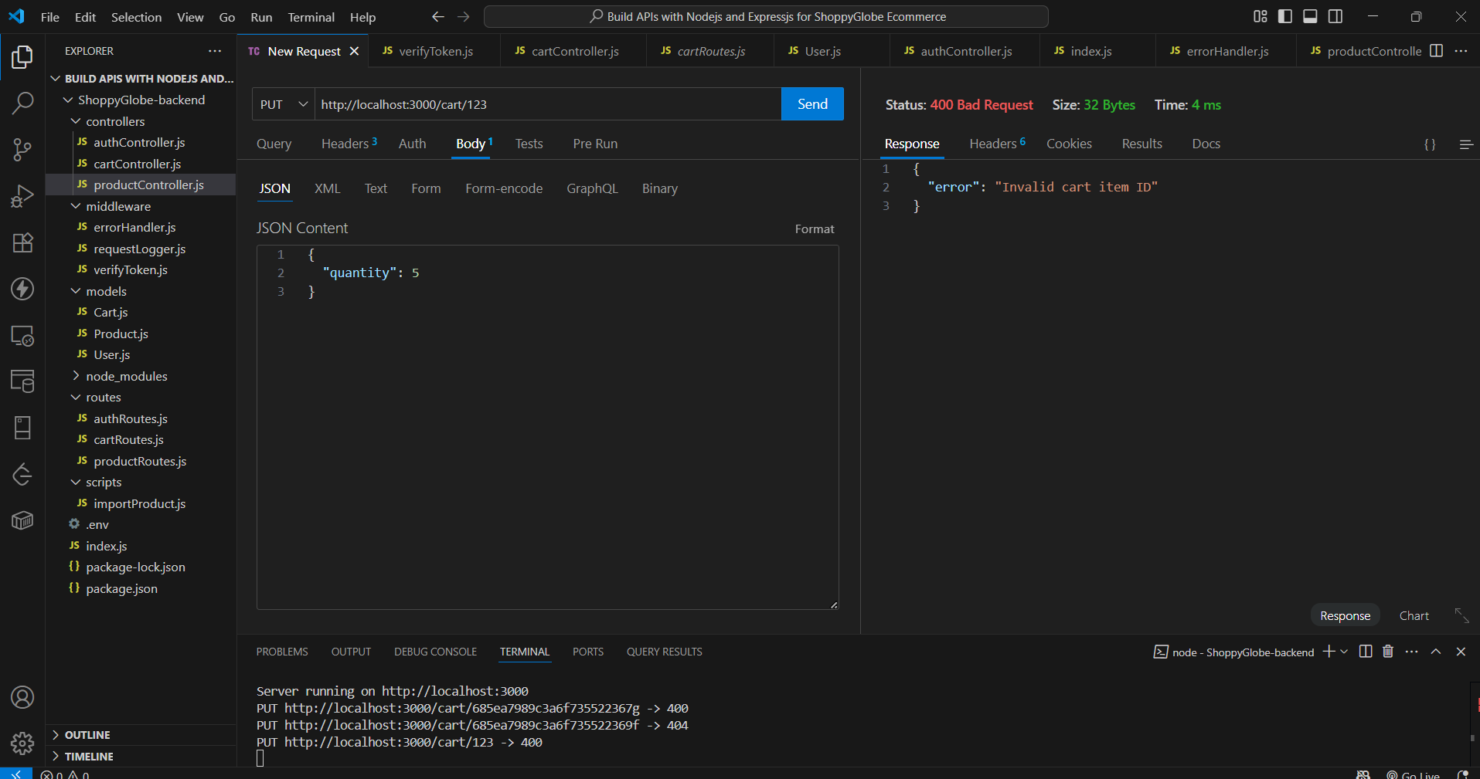

## 

## **6. DELETE Cart Item**

**Route:** DELETE /cart/:id  
**Headers:** Authorization: JWT <token>

**Success Response (200):**

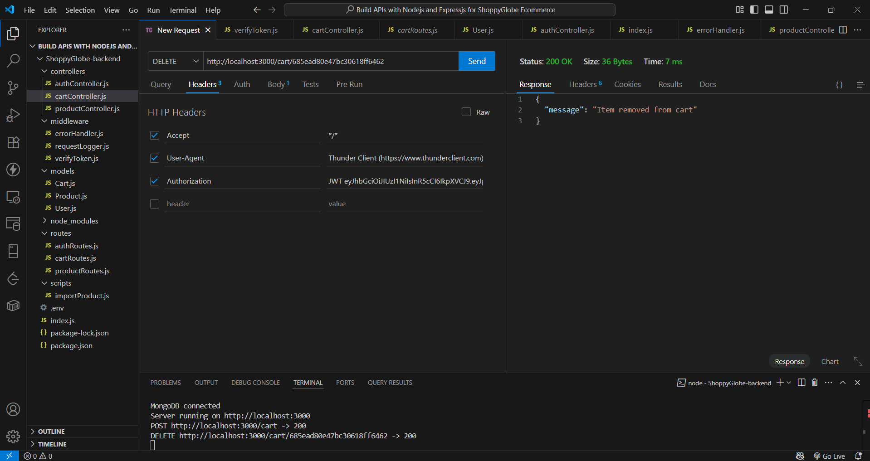

**Mongo Compass item is removed from the cart**

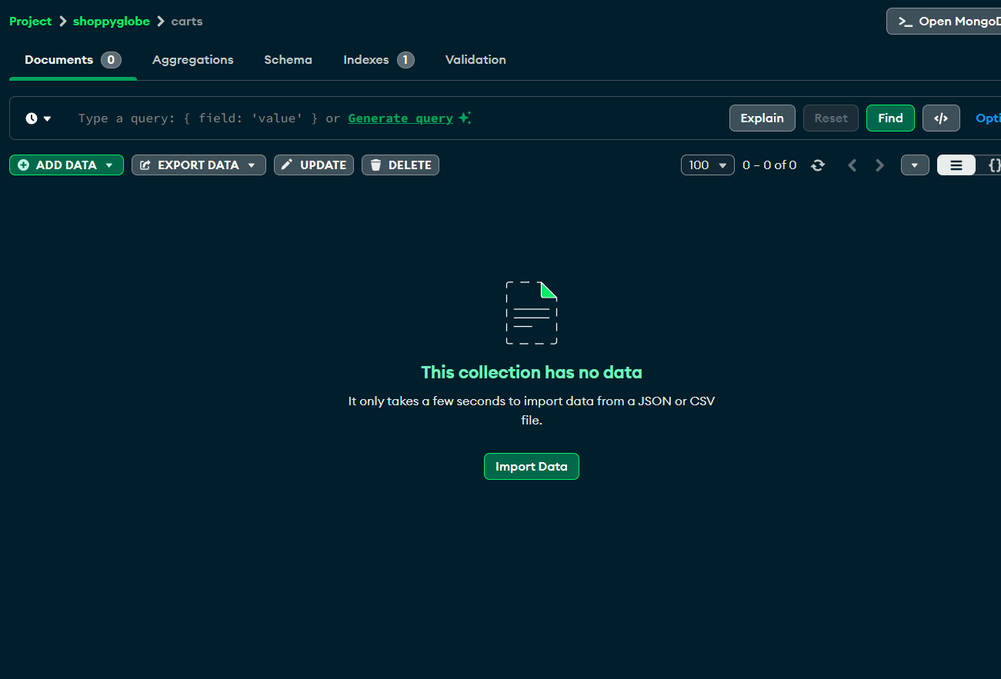

**Error Response (404):**

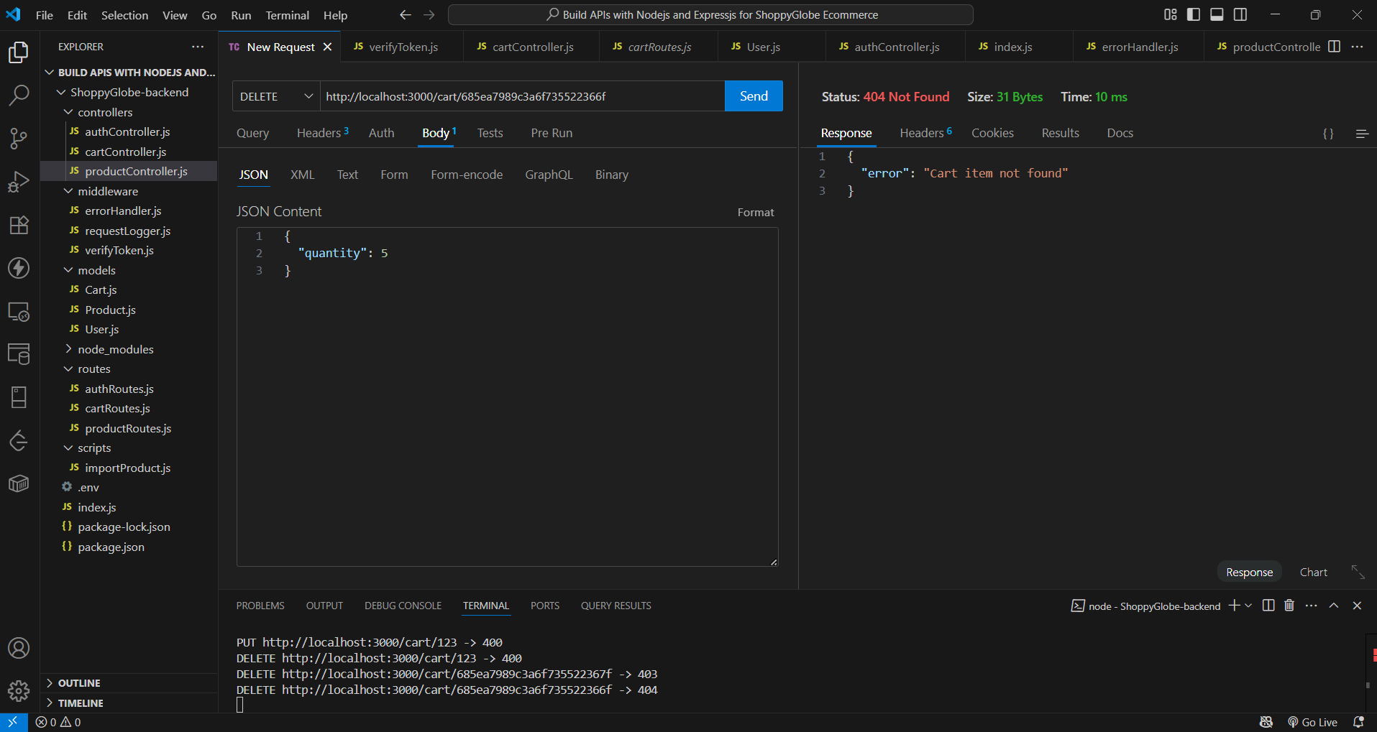

**Error Response (401):**

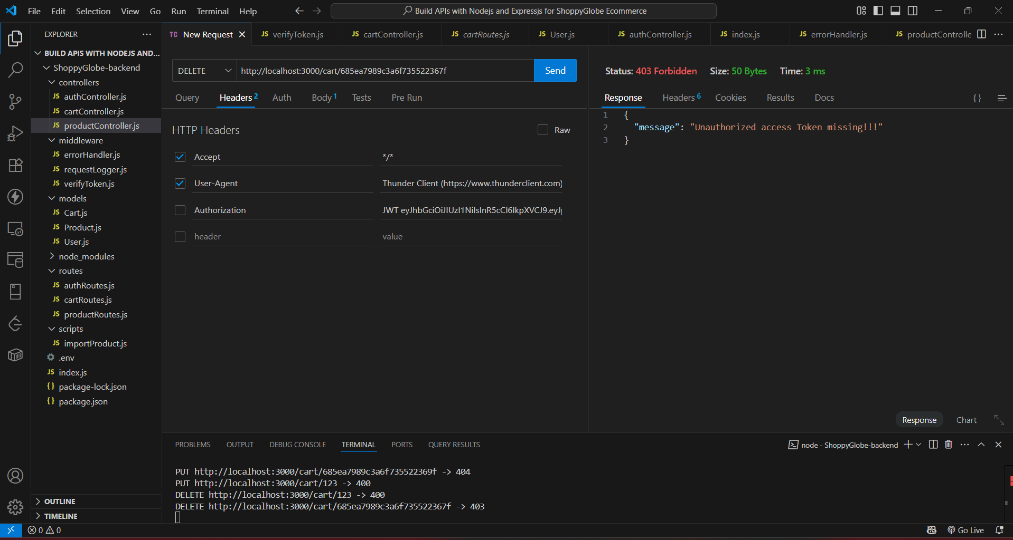

**Error Response(400):**

